### CS-639 Building User Interfaces, Fall 2020, Professor Mutlu

# Dialogflow *𝛼* (3 Points) Experience Prototyping Conversational Interactions

In this assignment, you will start your work toward designing and developing your Module 3 deliverable. We discussed in class that designing conversational interfaces has unique challenges and that ideation and prototyping methods that work very well in other design problems do not work well here. The good news is that we are also subject matter experts in conversation, but the bad news is that our expertise is encoded in our brains and is not readily available for us to use, what we called *tacit knowledge*. This is where *experience prototyping* comes into the picture: by simulating the social and/or the physical setting for the interaction and acting out the interactions using methods such as *bodystorming*, we unlock our expert knowledge and apply it to the design problem.

In this assignment, you will engage in experience prototyping for a *conversational shopping assistant*, which will serve as the basis for developing the intents and entities for the first prototype of your Dialogflow implementation. Specifically, the Dialogflow β tasks provided below should inform the development of the scenarios in Part 1, and the bodystorming of these tasks in Part 1 should be the basis for the specification of the intents, entities, and responses in Part 2.

**Part 1. Experience Prototyping (1.5 Points).** The first part of the assignment will involve engaging in *bodystorming* to generate ideas and specifications for your shopping assistant.

**Part 2. Agent Specification (1.5 points).** In the second part of the assignment, you will build on the outcome of your experience prototyping activity to develop specifications for the agent you will build in Dialogflow.

# Submission Details

You will submit a completed version of this document in PDF format to Canvas.

**Part 1. Experience Prototyping (1.5 Points).** In this step, you will follow a process very similar to the process we followed for the in-class activity on experience prototyping, paying particular attention to *bodystorming* for idea generation. In the context of designing a shopping assistant robot, follow the steps below:

1. *Define context —* This is given to you: users interacting with a conversational shopping assistant embedded within a clothing retail website. There is no deliverable for this step.
2. *Develop scenarios* — Think about how the shopping assistant will help users. What are some tasks the shopping assistant can help users with? Develop 3 scenarios. The tasks from Dialogflow β (provided below) should be the basis of these scenarios. Reviewing the [WiscShop API readme](https://github.com/wisc-hci-curriculum/WiscShop/blob/master/README.md) will also be helpful in developing your scenarios.
3. *Identify design goals* — Determine what the shopping assistants can do to assist in these tasks. Consider aspects of the task where the assistant can bring added value. Our goal is not designing a fully autonomous assistant that could take care of everything with minimal input from the user, but what is called a *mixed-initiative design* where the assistant does what it’s good at and the user does what the user is good at.
4. *Setup environment* — You can use the retail store provided with Module 3 starter code and/or another clothing retail store as your environment or prop during your acting.
5. *Act out interaction* — Ask a friend, family member, or another student in class to help you bodystorm user interactions with the shopping assistant to develop ideas and to more concretely define user and system behavior and interactions with the environment. Act out and record a transcript on at least one interaction for each scenario.
6. *Develop insight* — Capture the conversations from your bodystorming session and any other insight you have gained from the previous step in notes and translate them into a flowchart representation of the interaction.

Tasks that your Dialogflow β agent should support are listed below:

* **Login**
  + User is able to login with username and password. You do not need to handle account creation.
  + **NOTE:** It is sufficient if the user enters this information as a text query (typing), in case the username and/or password is hard to parse. It should still be english, e.g. "Log in with username <username> and password <password>."
* **Queries**
  + *Categories:* User should be able to query about the types of products offered.
  + *Tags:* User should be able to inquire about the types of tags for a specific category.
  + *Cart:* User should be able to request information about what is in their cart (e.g. total number and type of items, total cost, etc.).
  + *Product Info:* User should be able to request information about a product. If the product has reviews, they should be able to inquire about reviews and average ratings.
* **Actions**
  + *Tags:* User should be able to narrow down the search results within a category by specifying tags, e.g. "Show me all the red ones".
  + *Cart:* User should be able to add/remove items (or multiple of an item) to/from your cart. They should also be able to clear their cart.
  + *Cart Confirm:* User should be able to review, then confirm their cart.
* **Navigation**
  + User should be able to navigate through the application with the voice assistant using natural language, e.g., "Take me to the home page" or "Show me the hats".
  + For a full breakdown of the various routes in the application, see the WiscShop readme.

Your deliverables will be the scenarios and design goals you have focused on, the transcripts of the bodystorming sessions, and a flowchart representation of the conversational capabilities suggested by your experience prototyping through your 3 scenarios. Your flowcharts can be in the form of a graph where the nodes are system behaviors and arrows are user behaviors. To generate flowcharts, you can use [SmartDraw](https://cloud.smartdraw.com/) (using your NetID login) or free versions of other tools, such as [LucidChart](https://www.lucidchart.com/pages/) or [Creatly](https://creately.com/diagram-type/flowchart).

<scenarios-and-design-goals>

Scenarios:

* Adding a product to the cart
* Viewing a product’s detail
* Making a payment

Design goals:

* The shopping assistant will help the user narrow down their search by filtering out the results within the specified category
* The shopping assistant will help the user add and remove items from the cart
* The shopping assistant will enable the user to review the items in cart and confirm the cart

<bodystorming-transcripts>

**Scenario 1: Adding a product to the cart**

**Assistant**: Hi, welcome to <shopping-app-name>, what can I get you for today’s shopping?

Assistant provides the user with a piece of paper containing the full list of products sorted by categories, each product is represented by a piece of sticky note, and their detailed information and tags is shown on the note.

**User**: I would like to buy a shirt.

**Assistant**: Sounds good! I’ve found some great shirts for you.

Assistant puts the sticky notes of the shirt category onto a new piece of paper (a new screen) and shows a list of available shirts

**User**: Show me all the checked shirts.

**Assistant**: Here are the top picks for checked shirts.

Assistant removes all the shirts without a “checked” tag and leaves all the shirts tagged checked. User picked a sticky note from the paper.

**Scenario 2: Viewing details of a product**

**User**: Can you show me the details of this shirt?

**Assistant**: Sure! Name: Jump Around Shirt. Description: You will be ready for football season with this Jump Around t-shirt! The red tee features 'Jump Around' with a printed Wisconsin motion W and an Under Armour logo across the front. The soft shirt feels great and wicks away sweat on hot days. Price: $30.0. This item is in stock.

**User:** Sounds good.

**Assistant**: Would you like me to add this to your cart?

**User:** Yes, please.

Assistant moves the sticky note of the red shirt into a box representing the cart.

**Assistant**: Looks good! The shirt is added to your cart. Would you like to check out right now?

**User**: Yes.

**Scenario 3 – Making a payment**

Assistant shows user the box containing selected products.

**Assistant**: There is one item in your cart. They are: Jump Around Shirt of $30.0. Your total is $32.08 with tax. You are eligible for standard shipping. Would you like me to make the payment or go back shopping?

**User**: Make the payment.

**Assistant**: Which payment method would you like?

**User**: I will go with my Discover card.

**Assistant**: Your Discover card will be billed $30.08 for this order. Would you like to confirm?

**User**: Yes.

**Assistant**: Payment successfully completed. Thank you for your order! Would you like to continue shopping?

**User**: No.

**Assistant**: Alright. Have a good rest of the day!

<flowchart>

See next page.

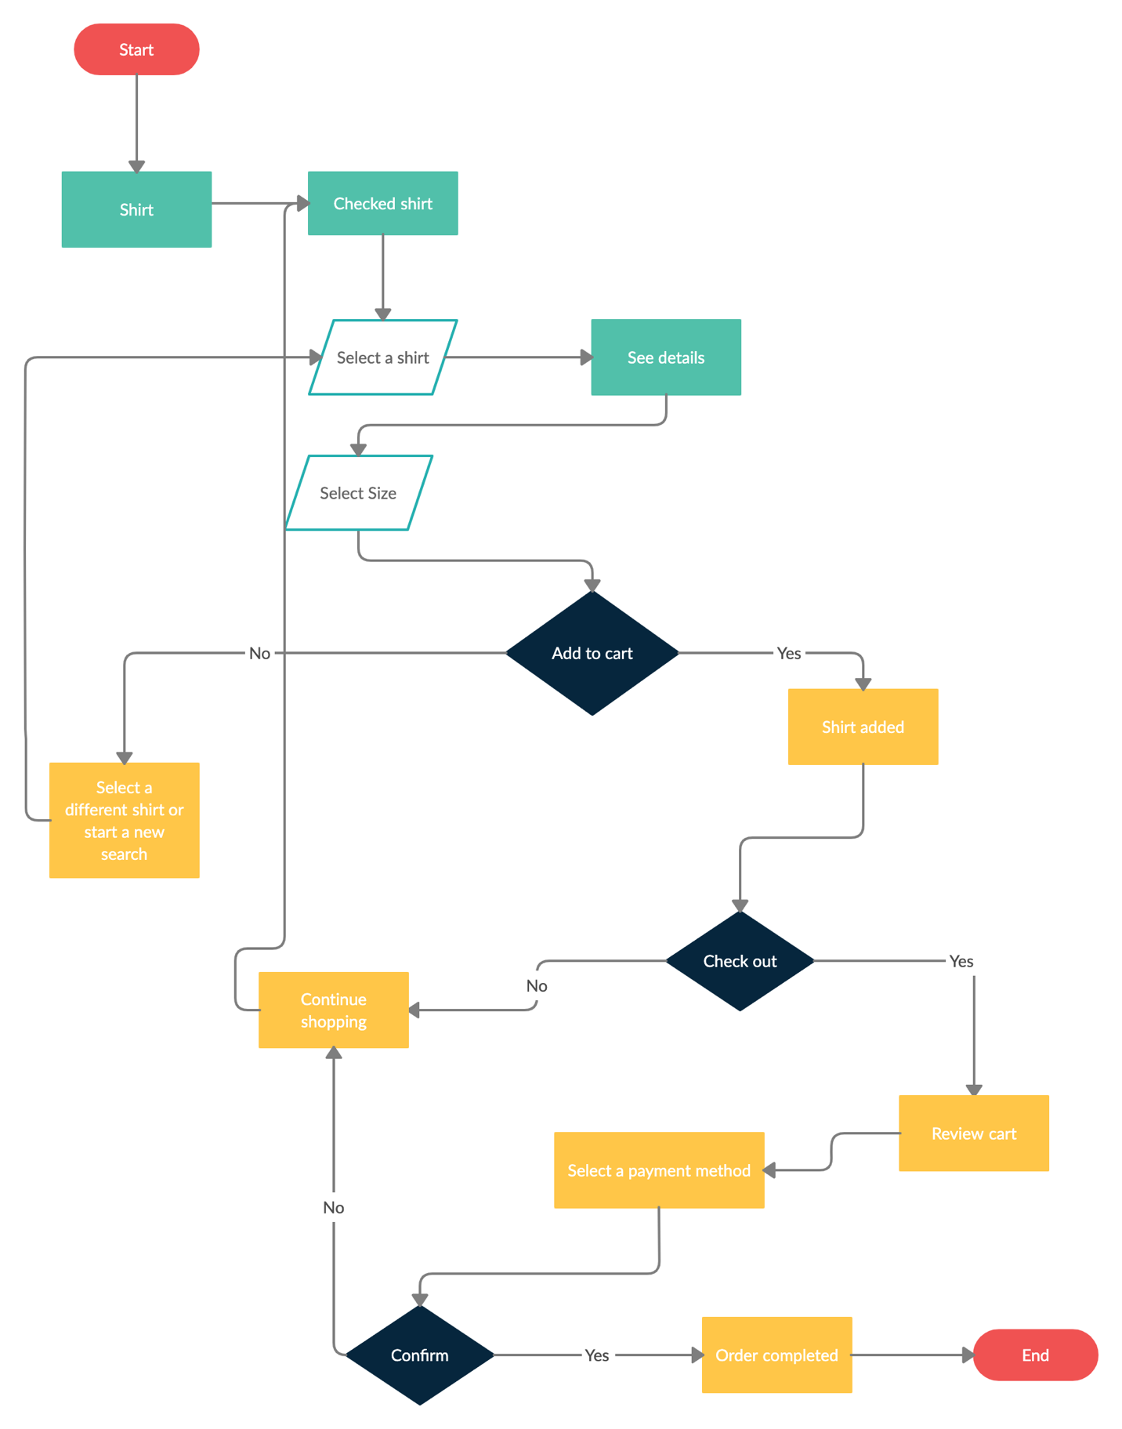

**Part 2. Agent Specification (1.5 Points).** In this step, you will apply what you learned in your experience prototyping activity to the design of the agent you will be creating. More specifically, you will draw on the outcome of your bodystorming session to determine the *intents* and *entities* that your agent will utilize in its conversation, and consider how you will use them and server data to provide responses.

If a particular intent or response is infeasible to implement the way you imagined in your bodystorming session, explain why, and propose an intent or family of intents which can be realistically implemented using the Dialogflow framework that will support the same functionality.

In this part, you will provide three main deliverables:

1. A list of all *intents* you will use (provide 10 training examples for each intent).
2. A list of all *entities* (provide at least five examples for each entity) you will be using with your agent.
3. For each *intent*, develop agent responses, specifically what it will *say in reply* (at least three responses to avoid repetition) and what it will *do* to change the GUI.

For a full description of what the GUI can do, and the requirements of the agent, see the Dialogflow β assignment details and the [WiscShop API readme](https://github.com/wisc-hci-curriculum/WiscShop/blob/master/README.md).

<intents-and-training-examples>

**Intent 1**: Narrow down the search results

1. “Could you show my all the jeans?”
2. “Show me all the midi-dresses.”
3. “Show me the best-reviewed shirts.”
4. “I would like to buy a grey skirt.”
5. “I want a fluffy white shirt with a Badger icon on it.”
6. “Do you have purple sneakers?”
7. “Can you help me find an olive wool coat?”
8. “Please find all the sneakers that are in black and white.”
9. “Show me all the ones that are under $20.”
10. “Show me all the checked shirts that are in stock.”

**Intent 2**: Review the cart and check out

1. “What’s in my cart right now?”
2. “I would like to check out.”
3. “May I check out, please?”
4. “I think I am good to make the payment.”
5. “Let’s go to the cart.”
6. “Can I see me cart?”
7. “Was the red shirt added to my cart?”
8. “I want to make the payment.”
9. “How many items are in cart right now?”
10. “What’s my total cost now?”

**Intent 3**: View the details of a product

1. “Can you show me more information about this red shirt?”
2. “What’s the price of this shirt?”
3. “What do the reviews say about this shirt?”
4. “Show me the picture of this shirt.”
5. “Can you give me a detailed description about this item?”
6. “How much does it cost?”
7. “What are the tags of this flannel shirt?”
8. “Is this shirt made of cotton or flannel?”
9. “What’s the rating of this tank top?”
10. “What’s the color of this shirt?”

**Intent 4**: Add to / Remove from cart

1. “Add this red shirt to my cart.”
2. “I want this floral-printed dress.”
3. “Clear my cart.”
4. “I don’t want the red shirt anymore.”
5. “Empty the cart for me, please.”
6. “I would like to buy two of these mom jeans.”
7. “Replace the black pants with this nice yellow pair.”
8. “Remove the red shirt from my cart.”
9. “I no longer want to but the pink dress.”
10. “I will only take one of those mom jeans.”

<entities-and-examples>

**Entity 1**: Category

Outwear, Shirts, Sweaters, Jeans, Innerwear, Dresses

**Entity 2**: Tag

Cashmere, Hooded, Fluffy, Cotton, Badger, Red

**Entity 3**: Product

Black mom jeans of $29

Green wool coat of $129

Purple cardigan of $40

Red Badger Tee of $ 30

Blue Nike Sneakers of $150

<intent-responses-and-procedures>

**Intent 1**: Narrow down the search results

1. “Okay. Here are all the red shirts.”
2. “Sorry, we don’t have any grey skirts available right now.”
3. “There are a total of 30 search results for floral-printed purple dress.”

**Intent 2**: Review the cart and check out

1. “Sure. There are a total of 3 items in your cart. Your total is $200. They are: <all-products-in-cart>. You total is $200. Would you like me to make the payment or go back shopping?
2. “Of course! Please review your cart and let me know if you need anything else or need to check out.”
3. “Are you sure you would like to confirm your payment?”

**Intent 3**: View the details of a product

1. “Yep, the product is Jump Around Shirt. Description: You will be ready for football season with this Jump Around t-shirt! The red tee features 'Jump Around' with a printed Wisconsin motion W and an Under Armour logo across the front. The soft shirt feels great and wicks away sweat on hot days. Price: $30.0. This item is in stock.
2. “The rating of this dress is 4.0/5.0. I have selected some top reviews for you.”
3. “The shirt costs $29. Do you want me to add it to your cart?”

**Intent 4**: Add to / Remove from cart

1. “The shirt is added to your cart. Would you like me to check out or continue shopping?”
2. “Are you sure you would like to empty your cart?”
3. “Jump Around t-shirt is removed from your cart.”